Form of Offshore Co (CA02e - c) |  |  |  |  | Att:
Applicant: |  |  | E-mail:
Contact No: | Mobile: |  | Fax No:
❒ New Incorporation  Buy Ready-Made Company

Jurisdictions:  BVI  Seychelles  Cayman Islands  Bahamas  Samoa

❒ Bermuda  Nevada  Delaware  Marshall Islands  Vanuatu

Company Name 1st Choice |  |  | (Chi)
(Note 1) |  |  | (Eng)
Company Name 2nd Choice |  |  | (Chi)
 |  |  | (Eng)
 |  |  |  |  | Total No. of share:
 |  |  |  |  | Face value per share: |  | US$
Director | Name (Eng): |  |  |  |  | ID Card / Passport/ CI No:
Subscriber | (Chi): |  |  |  |  | Issuing Country: |  |  | No. of shares:
(Note3) | Address:

Director | Name (Eng): |  | ID Card / Passport/ CI No:
Subscriber | (Chi): |  | Issuing Country: |  | No. of shares:
 | Address:

Company |  | Name (Eng): |  |  |  |  | ID Card / Passport/ CI No:
Secretary |  | (Chi): |  |  |  |  | Issuing Country: |  | Hong Kong
(Note 4) |  | Address:
(Note 5)
Corresponding Address:
How to know us: |  |  |  | ❒ Magazine  Newspaper  Leaflet  Search from Internet  Referral
Other
Information
Declaration I hereby agree and authorize Conson Limited to incorporate the above-mentioned offshore company, and certify that the above information is true and correct and agree to pay the related fees on incorporation.

Date: |  |  |  |  |  | Name and Signature of Applicant:

Information and Fee Schedule of Jurisdictions
* Over 2 directors / shareholders charge Ұ100 extra cost per person.
Jurisdictions | Formation fee | Annual fee |  | Time | Additional Chinese name
BVI – New | Ұ 8,700 | Ұ 7,900 |  | 14 Days | Ұ 1,000.00
BVI – Ready Made | Ұ 5,900 | Ұ 5,800 |  | 3 Days | Ұ 500.00
Marshall Islands | Ұ 6,300 | Ұ 7,000 |  | 5 Days | Ұ 1,000.00
Seychelles | Ұ 6,300 | Ұ 8,000 |  | 14 Days | Ұ 1,000.00
Cayman Islands | Ұ 21,000 | Ұ 21,000 |  | 30 Days | Ұ 2,200.00
Bahamas | Ұ 6,500 | Ұ 7,400 |  | 22 Days | Not providing
Samoa | Ұ 6,000 | Ұ 7,000 |  | 14 Days | Ұ 1,000.00
Bermuda | Ұ 96,000 | Ұ 48,000 |  | 7 Days | free
Nevada | Ұ 11,000 | Ұ 10,000 |  | 24 Days | Not providing
Delaware | Ұ 8,000 | Ұ 7,400 |  | 24 Days | Not providing
Anguilla | Ұ 6,700 | Ұ 7,400 |  | 24 Days | Not providing
Mauritius- GBL2 | Ұ27,000 | Ұ 15,000 |  | 30 Days | Ұ 2,200.00
Singapore | Ұ 35,000 | Ұ 22,000 |  | 30 Days | Not providing
Vanuatu  Free – Certificate of Incumbency | Ұ 13,500 | Ұ 8,900 |  | 7 Days | Ұ 1,000.00
Process of New Incorporation |  |  | Process of Buying a Ready-made Company
- Searching for the intended company name  (more choices are recommended) |  |  | 1. Select a suitable name from the company list (more choices are recommended)
2. Client provide information to us (complete the Application Form CA02 and send us by fax or e-mail together with Identity Document copy of all members)
3. Client sign on the prepared documents
- Provision of company chop, document of open bank account, share book, M&A, register documents….etc.
- Incorporation process completed, client collect all the document and visit bank to open bank account

Services Included  - Company Name Search;  - Certificate of Incorporate for offshore company;  - Memorandum and Articles of Association;  - Company Share Book and Register Documents;  - Provision of Company Chop & Common Seal;  - Submit the Notification of First Director, Secretary;  - Preparing the Certified True Copies;  - Minutes for opening bank account. | 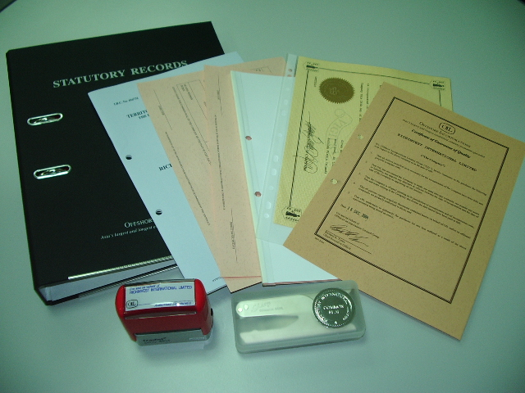

Secretarial Service: One Year (4 sets of documents)
Fee: RMB 1,400
- Conson be a Company Secretary
- Free of Increase / Decrease number of director or Shareholder
- enjoy Ұ200 discount as following

Other Services

Services | BVI | Seychelles |  | Marshall Islands | Samoa |  | Delaware |  | Bermuda | Bahamas
Authorized Capital | 50,000 share | US$1,000,000 |  | US$50,000 | US$1,000,000 |  | 1500 share |  | US12,000 | US$50,000
Annual License Fee ( month ) | 4 & 10 | 3,6,9,12 |  | Anniversary date | 10 |  | 2 |  | 12 | 11
Increase / Decrease number of director | Ұ 500 | Ұ 500 |  | Ұ 500 | Ұ 500 |  | Ұ 500 |  | On  quotation | Ұ 1,000
Increase / Decrease number of shareholder | Ұ 500 | Ұ 500 |  | Ұ 500 | Ұ 500 |  | Ұ 500 |  | On  quotation | Ұ 1,000
Change Co English Name | Ұ 3,000 | Ұ 3,000 |  | Ұ 3,000 | Ұ 3,000 |  | Ұ 3,500 |  | On  quotation | Ұ 3,200
Change Co English & Chinese Name | Ұ 3,800 | Ұ 3,800 |  | Ұ 3,800 | Ұ 3,800 |  | -- |  | On  quotation | --
Certificate of Incumbency | Ұ 1,000 | Ұ 1,500 |  | Ұ 1,000 | Ұ 1,500 |  | Ұ 1,500 |  | On  quotation | Ұ 2,200
Certificate of Good Standing | Ұ 1,500 | Ұ 1,500 |  | Ұ 1,200 | Ұ 1,500 |  | Ұ 2,000 |  | $4,600 | Ұ 1,800
Increase Authorised Capital | Ұ 8,000 | Ұ 8,000 |  | Ұ 4,500 | Ұ 2,600 |  | On  quotation |  |  | Ұ 9,000
Annual fee after increase capital | Ұ 12,200 | Ұ 5,400 |  | Ұ 5,400 | Ұ 5,500 |  |  |  |  | Ұ 12,000
Services |  |  | Nevada |  |  | Anguilla |  | Cayman Islands
Authorized Capital |  |  | US$50,000 |  |  | US$1,000,000 |  | US$50,000
Annual License Fee ( month ) |  |  | Anniversary date |  |  | Anniversary date |  | 12
Increase / Decrease number of director |  |  | Ұ 500 |  |  | Ұ 500 |  | Ұ 3,800  ( per case )
Increase / Decrease number of shareholder |  |  | Ұ 500 |  |  | Ұ 500 |  | Ұ 3,800  ( per case )
Change Company English Name |  |  | Ұ 3,000 |  |  | Ұ 3,000 |  | Ұ 5,500
Change Company English & Chinese Name |  |  | Ұ 3,500 |  |  | Ұ 3,500 |  | Ұ 7,500
Certificate of Incumbency |  |  | Ұ 1,500 |  |  | Ұ 1,500 |  | Ұ 3,200
Certificate of Good Standing |  |  | Ұ 2,500 |  |  | Ұ 2,500 |  | Ұ 4,000
Increase Authorised Capital |  |  | On quotation
Annual fee after increase capital

* Notice
- The Service Fee will base on the Offshore government and Agency.
- In order to comply with the new anti-money laundering guidelines, the regulation and procedures on opening offshore company bank account are more constricted. It is advised to clearly understand the procedures and the requirement of banks. Should you have any inquiry, please feel free to contact us.

** Please noted that above price only for our China branch client. Fee quoted may be subject to change.

